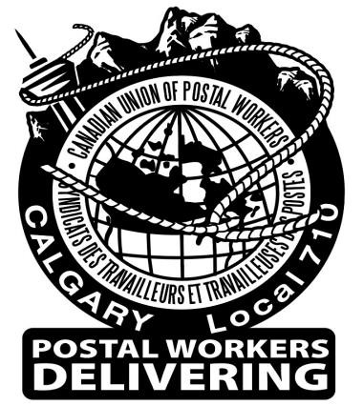
Cupw Calgary Local 710

Constitution Resolution Meeting

@ Local Union Hall
# 109 - 5621-11 Street, NE Calgary

September 10th, 2026 @ 4pm

Calgary Local 710 Members are invited to submit Resolutions outlining their proposed amendments to the CUPW Constitution. Resolution must be received by the Local Office before the commencement of this meeting.

Deadline for submissions:

You can submit them in person or send via email to the Secretary Treasurer by: Thursday September 10th, 2026 @ 4pm.

The resolutions will be debated and voted upon, those which are passed will be submitted to Regional Office.

Regional Office will then amalgamate the resolutions received from all Locals and those will be debated at the Regional Conference by all the delegates who are in attendance.

- Prairie Regional Conference – November 5 - 8, 2026
- National Convention May 17- 21, 2027 – Toronto, ON

If you need assistance in writing a resolution, feel free to contact us on 403-295-2556 or email sec-treas@cupwcalgary.org. An example has been posted on our website and local Facebook page.

In Solidarity,
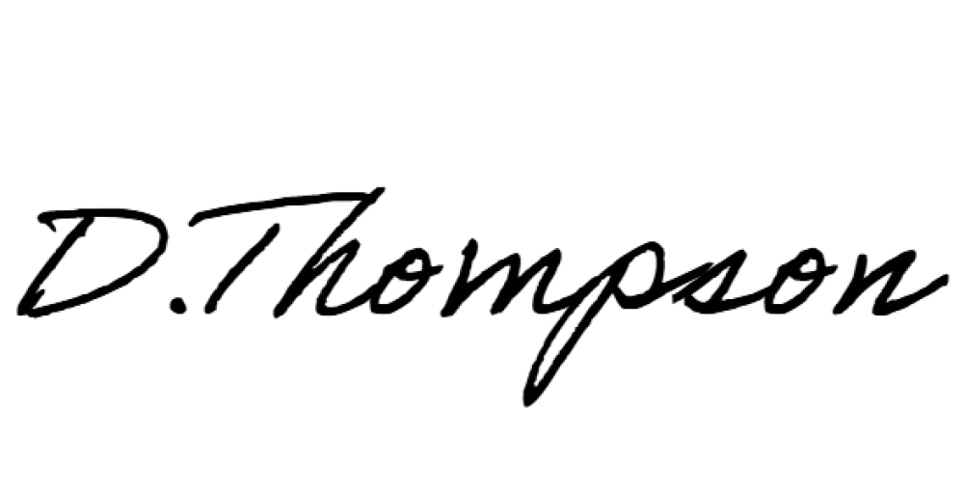

Danielle Thompson
Secretary Treasurer,
Calgary Local 710

CUPW respectfully acknowledges this office is located on the traditional unceded territories of the Niitsitapi & the people of the Treaty 7 Region in Southern Alberta.
Posted week of: July 19th, 2026

